**EXPERIMENT 6**

**Aim:** Introduction to Cisco Packet Tracer

**Theory:**

Cisco developed the Packet Tracer software to help Networking Academy students gain practical

networking technology skills in a rapidly changing environment. Packet Tracer is a powerful

network simulation program which allows students to experiment with network behavior and ask

'what if' questions. It supplements physical equipment in the classroom by allowing students to

create a network with an almost unlimited number of devices, encouraging practice, discovery and

troubleshooting. Started in 1997, Cisco Networking Academy is an IT & Networking skill and

career building program for learning institutions and individuals worldwide.

Packet Tracer complements the Networking Academy curricula, allowing instructors to easily teach

and demonstrate complex technical concepts and networking systems design. Instructors can

customize individual or multiuser activities, providing hands-on lessons for students that offer value

and relevance in their classrooms. Students can build, configure, and troubleshoot networks using

virtual equipment and simulated connections, alone or in collaboration with other students. Packet

Tracer offers an effective, interactive environment for learning networking concepts and protocols.

Most importantly, Packet Tracer helps students and instructors create their own virtual “network

Worlds for exploration, experimentation, and explanation of networking concepts and

technologies.

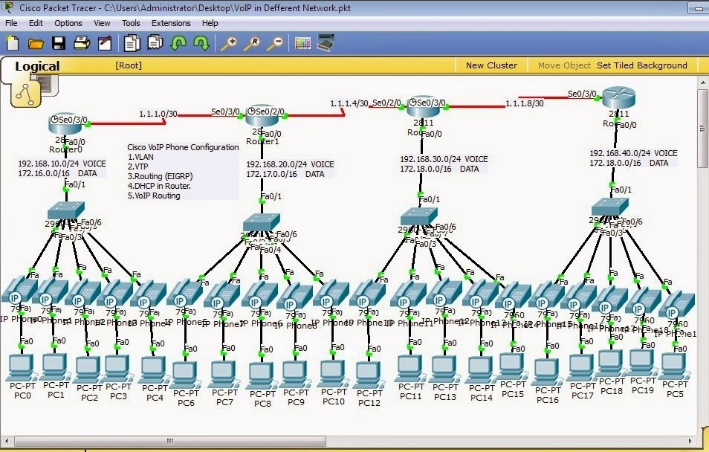

Packet Tracer Modes: Cisco Packet Tracer provides two operating modes to visualize the behaviour of a network—real-time mode and simulation mode. In real-time mode the network behaves as real devices do, with immediate real-time response for all network activities. The real-time mode gives students a viable alternative to real equipment and allows them to gain configuration practice before working with real equipment. In simulation mode the user can see and control time intervals, the inner workings of data transfer, and the propagation of data.

**Workspace:**

* Logical – Logical workspace shows the logical network topology of the network the user has built. It represents the placing, connecting and clustering virtual network devices.
* Physical – Physical workspace shows the graphical physical dimension of the logical network. It depicts the scale and placement in how network devices such as routers, switches and hosts would look in a real environment. It also provides geographical representation of networks, including multiple buildings, cities and wiring closets.

**Key Features:**

* Unlimited devices
* E-learning
* Customize single/multi user activities
* Interactive Environment
* Visualizing Networks
* Real-time mode and Simulation mode
* Self-paced
* Supports majority of networking protocols
* International language support
* Cross platform compatibility

